Reference websites –

https://www.pandoraindia.com/lithium-carbonate

https://lohum.com/custom/Lithium_104

https://en.techtonejs.com/products/display/51

1. Headline:
Lithium Carbonate Supplier & Exporter from India – Battery & Industrial Grade Supply
Sub-line:
Reliable sourcing | Bulk supply | Competitive pricing vs global suppliers
Add CTA:
- Get Latest Price (FOB/CIF)
- Request COA & Specification

2. Lithium Carbonate (Li₂CO₃) is widely used in lithium-ion batteries, ceramics, glass, and specialty chemicals.
add:
- Available Grades:
  - Battery Grade (≥99.5%)
  - Technical / Industrial Grade
3. Contract Manufacturing
Controlled Production Through Partner Facilities

What this means:
- Production aligned to our quality parameters
- Batch consistency across shipments
- Ability to select raw material origin based on requirement
- Better control over purity and specifications

Flexible Sourcing + Manufacturing Model
- Multi-origin raw material sourcing (China / South America)
- Processing through trusted partner plants
- Custom specification supply based on applications
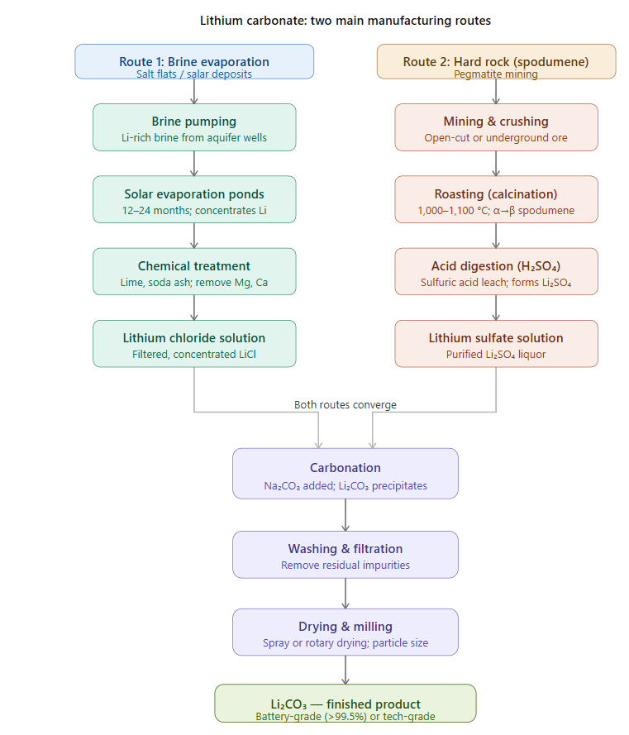

4.
